SCENARIO: | It is necessary to take the example at the end of the year 2022ACT Period 12.
AREA: | Entity and Consolidation Journals | STATUS: | OPEN / APPROVED
Responsible | Diego Felipe Rozo | EXECUTION  DATE (MM/DD/YYYY): |  | 08/04/2023

SYSTEM DATA
SYSTEM | ENVIRONMENT | DATE LAST VERSION (MM/DD/YYY) | VERSION
TUP – CCH Tagetik | ABC Inc. | 10/05/2022 | 5.3.21.303

Table of Contents
1. Entity and consolidation journal 3
1.1. Explanation 3
1.1.1. Entity journals 3
1.1.1.1 Entity journals (as well as the consolidation journals) logically consists of two parts: 3
1.1.2. Consolidation Journals 4
1.1.2.1 The consolidation journals (manual entry): 5
1.1.3. Consolidation Journal’s Rows 9
1.1.4. Reverse journal 9
1.1.4.1 Method 1 : "Set BS accounts to 0" Reverse journal type ("1") 10
1.1.4.2 Method 2: Set BS accounts to 0, Write off P&L impact (IC) ("2") 11
1.1.4.3 Method 3: Set BS accounts to 0, write off P&L impact and variations ("3") 12
2. Uploading Journal Data using an ETL: 15
2.1. Journal Data ETL Configuration 15
2.2. Journal Data Excel File Configuration 16
2.2.1. Entity Journal Upload File Sheets 16
2.2.2. Consolidation Journal Upload File Sheets 20
2.3. How to upload Journal Data using ETL 23
2.4. Common Errors 30
2.4.1. Error due to the value of the counterparty Entity: 30
2.4.2. Error due to the category that is different between the header and the row: 30
2.4.3. The account code doesn’t exist: 31
2.4.4. The Currency is different from the Header: 32

- Entity and consolidation journal
  - Explanation
The main differences between entity journal entries and consolidation journal entries are that Entity journals are used to make corrections to the original amounts in the individual entity's financial statements. That is, before consolidation. Whereas consolidation journals are used to correct or complete entries after consolidation such as adjustments to elimination of profit or loss, depreciation, etc.
    - Entity journals
Entity journals are "single-entity" data that represent "corrections" to the financial statement’s original amounts of the individual Entity.
Entity journals allow the user to "adapt" financial statements data with the group accounting principles without changing the original data, as they are made on a specific category type: "Entity journals".
Entity journals can be entered on original scenarios / periods by the contributor user and consolidator user on the “Entity journals” and “Consolidation journals” type categories.
There are two different ways of managing the Entity journals depending on the project type and client requirements:
- Standard management. This is the most complete mode whose use is recommended for all statutory consolidations. In this case, the journals are managed on a period-by-period basis and entered data are year-to-date.
- Periodic management. This choice is recommended in the case of management consolidation. In this case, the journals are managed from the selected period up to the end of the process. On single submission processes, for the periodic journals, a specific menu item will be available for the periodic management of the rows.

1.1.1.1 Entity journals (as well as the consolidation journals) logically consists of two parts:
- a header representing the "container" of the general attributes of the journals (code, description, ...) and where it is defined how the system should manage the journal (if it must be carried forward, on which consolidation scenarios it must be processed...)
- some rows. Several rows can be defined inside a header. The rows represent the movements saved in the system.
The manual insertion of the Entity journals can be done from the cockpit by clicking on the "Process" tile in the end-user's home page and then selecting the desired process (and the scenario / period if the process is not single submission).
The Entity journals management window can be accessed:
- from the Detail summary, via the "Edit windows" > "Edit Entity journals" button.
- from the tabs by step. If a task workflow containing an "Entity journals" type task is associated with the entity/ step, it is necessary to click on the task and then select the "Run" option. Otherwise, use the "Edit windows" > "Edit Entity journals" button.
In both cases, the system opens the Entity journal's headers management window of the selected Entities. If nodes are selected, then the Entity journals of the Entities belonging to these nodes will be displayed (recursively going down to the lowest level).
Enable carry-forward.
Specifies if the journal has to be carried forward in the following scenario. If "Override journal parameters" is not enabled, it is set up with the relevant value present in the categories table.
    - Consolidation Journals
The consolidation journals allow the consolidator user to:
- Complete / correct the journals generated by the system.
- Insert manual consolidation adjustment entries (for example elimination of the IC earnings, goodwill depreciation, dividends write off, etc.).

The management of such journals is analogous to the entity journals management; the only difference is the category to which they are attributed. Indeed, the consolidation journals are performed on the "Consolidation journals" categories.
Such journals are classified according to the consolidation operation type they represent. Available journal types:
- Dividends eliminations
- Financial investments depreciation/revaluation
- Financial investments elimination
- Net equity evaluation
- Net equity accounts reclassification
- IC eliminations
- currency conversion
- Minorities Calculation
- entities equity evaluation method
- mergers
- Deconsolidation
- Other Consolidation journals
The consolidation journals can be managed in three different ways according to the project type and to the client's requirements:
- Standard management. This is the most complete method, and it is recommended for all statutory consolidations. In this case the journals are managed by single period and inserted data are cumulated.
- Periodic management. This method is recommended for the management consolidation. In this case the journals are managed from the selected period to the end of the process.
- Synthetic Management. In this case the headers of the consolidation journals are grouped according to the set filters. For each grouping it is possible to display the detail and then proceed with the standard consolidation journals management.

1.1.2.1 The consolidation journals (manual entry):

The manual entry of the consolidation journals can be performed from the end-user web interface only from the consolidator process cockpit. To run the process cockpit, click on the "Processes" button (available on the end-user homepage and in the left pane, End User > Processes area) and then click on the desired cockpit.
The window will open the window for the management of the headers of the consolidation journals for that process.
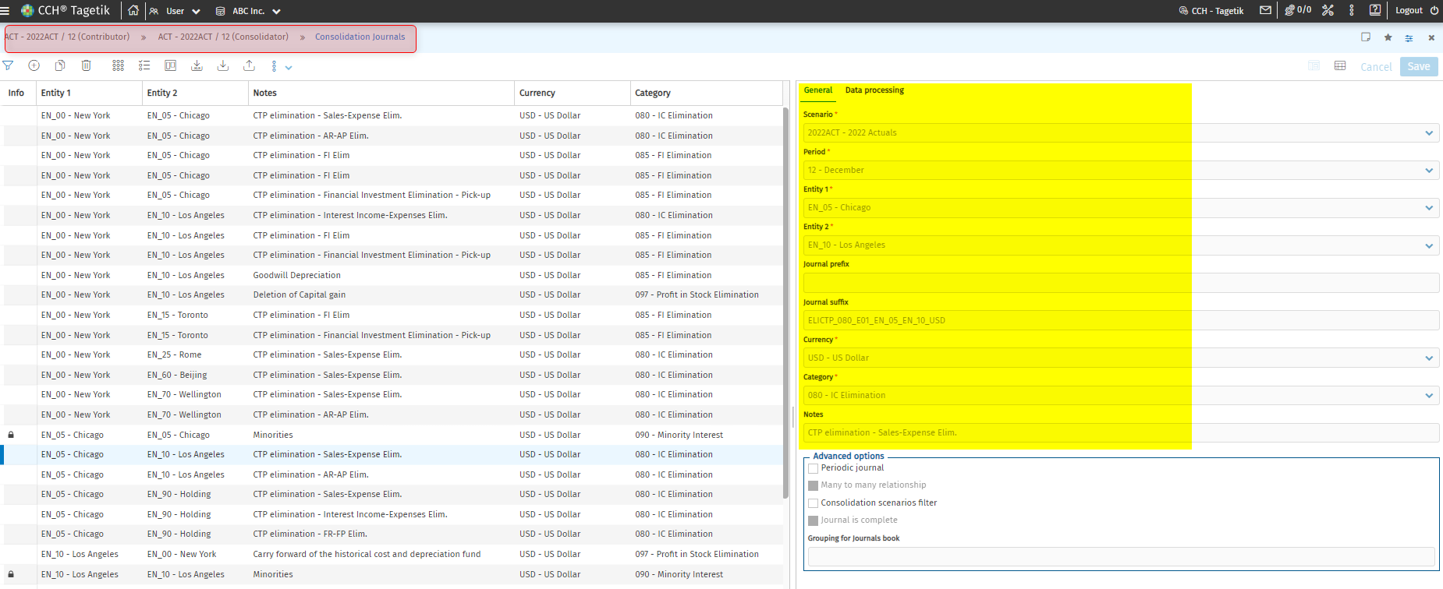
Screenshot 1 - Consolidation journals attributes
The window is divided into two areas:
the right-hand area » General tab
in which it is possible to insert the header of a new journal or modify an existing one. Each new header is identified by:
- a scenario/ period;
- the entity 1 and the entity 2 of the relationship in which the journal will be inserted
- a journal prefix. The system uses this information to create the journal number, namely the unique ID of the journal. By default the system uses the journal prefix set as the value of the Journal prefix create method information present in the journals advanced settings (the generic one accessible from the administrator user web interface by following the path Setup & Admin > Data Entry & reporting > Journal > Advanced settings or the one overridden for the process).
- a Journal suffix. The system uses this information to create the journal number, namely the unique ID of the journal.
- The unique ID of the journal is used to group "visually" the similar journals and to simplify the search for a specific journal type.
- The consolidation currency to which the journal has to be attributed. Generally it corresponds to the currency of the Holding.
- A Consolidation journals" category
Periodic journal. By enabling this option, the user declares that the journal is periodic and not cumulated. The periodic management can be performed:
- directly from the journal's rows management. In this case when saving, the system will save not only on the current period but also on all the following periods belonging to the same process.
- by using the “Periodic management”menu key available in the "Actions" menu of the headers management window. In this case the user can insert from a single window the journal's data for all the periods till the end of the process
- Possible additional notes
Moreover, if:
- the relationship type related to the process for which the journal is managed is “by Entity/Custom dimension 2"
- the management of the custom dimension 2 is enabled
- the management of the counterparty on individual data is enabled
The following dimensions can be managed as well:
- the ctp custom dimension 2 of the entity 1 (custom dimension 2 ctp 1) to which the journal must be attributed
- The ctp custom dimension 2 of the entity 2 (custom dimension 2 ctp2) to which the journal must be attributed
Data processing tab
Depending on the category assigned to the journal, the system helps the user create the journal's header by pre-setting the information contained in this box with the values assigned to such information in the categories table in the Default for manual journals box. Generally the journals attributed to the same category are processed and managed in the same way
- Proportional calculation method. It specifies the method by which the proportional calculation percentage has to be calculated
- Minorities calculation method. It specifies the method by which the minorities have to be calculated
- Equity evaluation method. It specifies how the system must behave during the equity evaluation on an Entity at equity.
- Tax calculation method. It specifies the deferred taxes calculation type
- Reverse journal type. It specifies if the journal must be reversed automatically by the system during the carry forward process and how
- Enable carry forward. It specifies if the journal must be carried forward in the following scenario
- Exclude Reclassifications and NER. It specifies whether or not the journal must be subjected to the Net Equity Account Reclassification

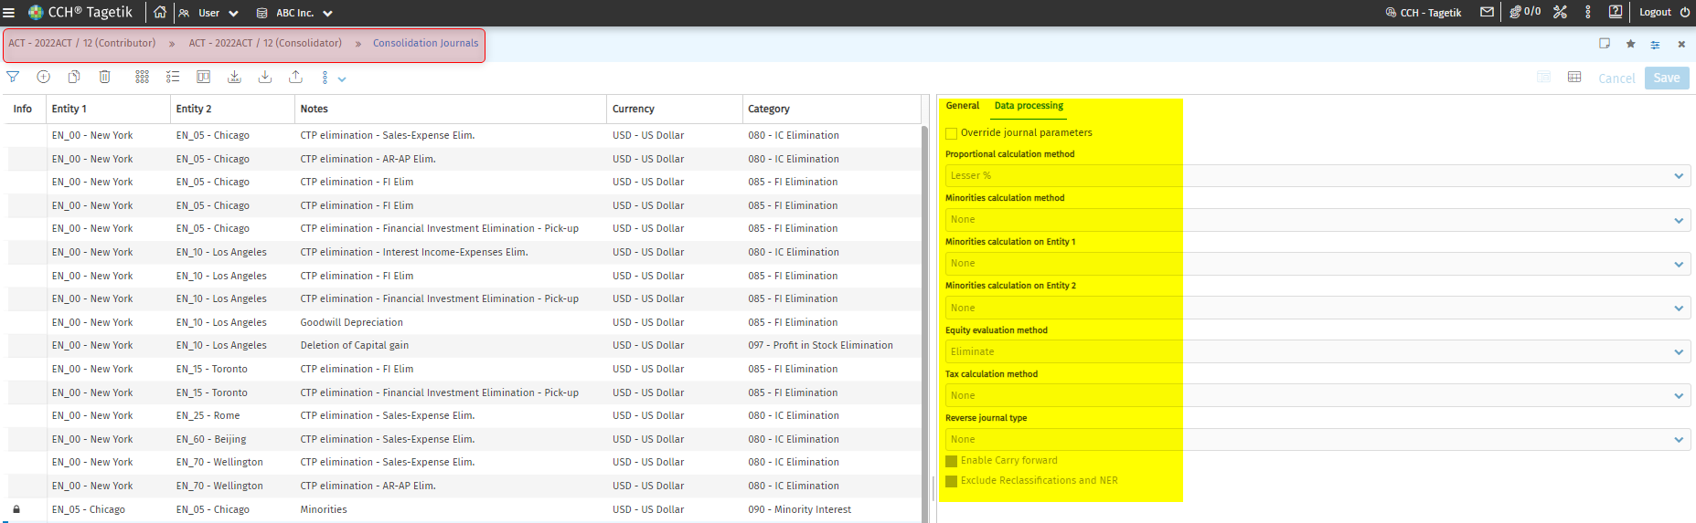
Screenshot 2 - Consolidation journal data processing options
Obviously the user can override such information in each single journal by enabling the "Override journal parameters " option. When this option is enabled, the value of such fields cannot be modified automatically by the system but only by a manual intervention.
- specify if the journal's rows include more entities than those specified on the header (Many to many relationship option enabled). So it is possible to insert some journals involving more than two entities but the system cannot generate relevant segment reports
- generally, the inclusion of a journal into a consolidation scenario is determined by the entity and by the category. Anyway the user can filter the consolidation scenarios in which a journal is considered by enabling the "Consolidation Scenarios filter" option. By enabling this option and double-clicking on the header, the system will open the "Rows and documents" window containing the "Consolidation scenarios" in which it is possible to choose the consolidation scenarios on which the journal has to be considered
- group several journals by assigning to them the same code (Grouping for Journals book). This code can be used, for example, in the journals book to call a specific set of journals
- Journal is complete option which specifies if the journal entry is completed
__________________________________________________________________________
__________________________________________________________________________

The left-hand area showing the existing headers;

 The system identifies:

- With the icon the headers which cannot be modified. By selecting the records labelled with this icon, the system below the grid the “Information” box containing the reason for the block;
- With the icon the balanced headers and with the icon the unbalanced headers

If the journals submission is enabled on at least one step for the application process, the system shows on the left side the progress status of this activity for each step for which it has been enabled.
The submission of the journals is very important for the manual journals (those journals whose rows have a manual origin). Through the filters window it is possible to choose to display only the journals containing "Manual rows", in order to work only on that specific subset of data.
__________________________________________________________________________ ________________________________________________________________________________________________________________________________________________________________
    - Consolidation Journal’s Rows
After defining the header of a consolidation journal, it is necessary to define its rows, namely the various entries which compose the journal. In order to define the rows which compose a journal, it is necessary to double-click on its header and select the "Original" tab of the "Rows" section.

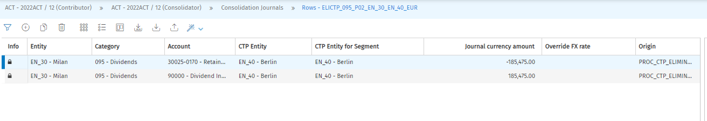
Screenshot 3 - Rows of a consolidation journal
Each row is identified by:
- The entity. If the "Many to many relationship" option is disabled on the journal's header, the user can select only one of the available entities on the header
- An account;
- The Journal currency amount
- The ctp entity. It must be specified only if the journals concerns IC data; generally, it must be inserted if the journal is used to delete an entry that was declared ctp in the financial statement of the entity
    - Reverse journal
The Reverse journal data processing is a Preliminary operation and is run on Entity data by filtering by entity and on Group data by filtering by node.
The operation is aimed at keeping analytical memory of all operations performed.
The possible reversion methods, to be set up on the journal's header, are:
- 1 - Set BS accounts to 0 (cut off)
- 2 - Set BS accounts to 0 and Write off P&L impact (IC)
- 3 - Set BS accounts to 0, Variations and Write off P&L impact
Usually, the reverse journal variations are converted by the "Initial balance FX rates" conversion type so that converted data, especially in case of normal accounts at historical FX rate, is totally written off by the reverse journal entry. Such FX rate is calculated along with the data processing and is obtained from the relationship of converted data and of proportional data of the normal account.
The reverse journal, like the carry forward, analyses data of the maximum period of the previous scenario.

1.1.4.1 Method 1 : "Set BS accounts to 0" Reverse journal type ("1")
The goal of this data processing is to "cancel" the effect of the journals having the "Reverse journal type" field of the header set to "Set BS accounts to 0".
This is useful, for example, when a journal (typically an Entity journal) is used to complete the balance sheet items of a given fiscal year but in the following year the same data are input as amounts; therefore, the journal will have to be carried forward and "deconsolidated".
It is run just after the carry forward and processed data have PREL_REVERSE1 origin.
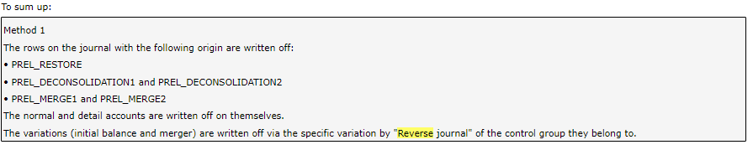
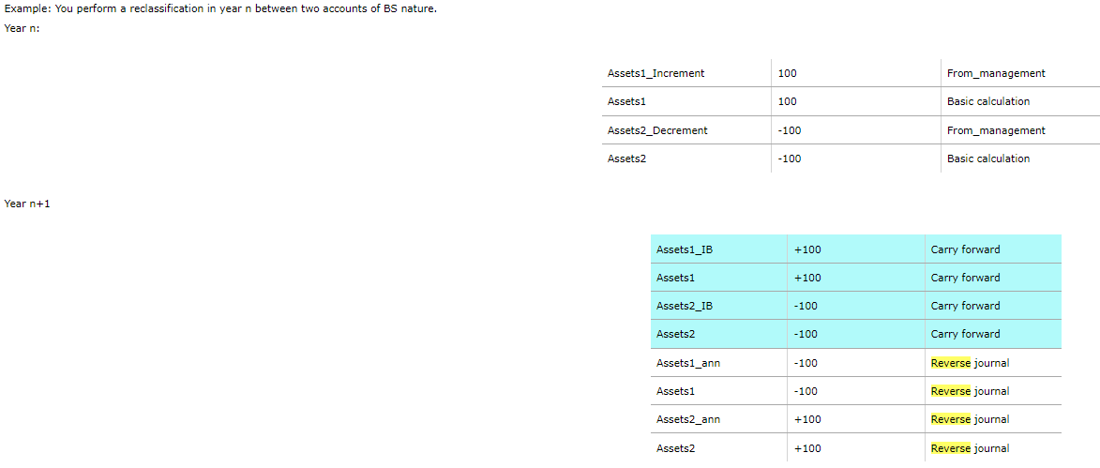

1.1.4.2 Method 2: Set BS accounts to 0, Write off P&L impact (IC) ("2")

This reverse journal type allows you to perform some specific carry forward entries which are useful especially for the BS elimination journals.
If this type of reverse journal is specified for a given journal, at the carry forward step the system runs the usual carry forward of the normal BS rows (but without carrying forward the details); then it cancels all the accounts of BS nature by inserting a row on the same account with amount with opposite sign and PREL_REVERSE2 origin. The cancellation does not include the net equity accounts, the accounts subject to the minorities calculation and the accounts specified as "Deferred taxes fund (debit/credit)" in the Fiscal Policies and Taxes table.
Moreover, the system cancels P&L impact of the carry forward scenario (normal and detail accounts) again by inserting a row on the same account with amount with opposite sign and PREL_REVERSE2 origin. With the exception of the P&L net result and the "deferred taxes (debit/ credit)" accounts included in the Fiscal Policies and Taxes table for which no write off operation is done.
The cancellation does not include also the rows allocated to the P&L accounts with PREL_REVERSE2 origin on the carry forward scenario.

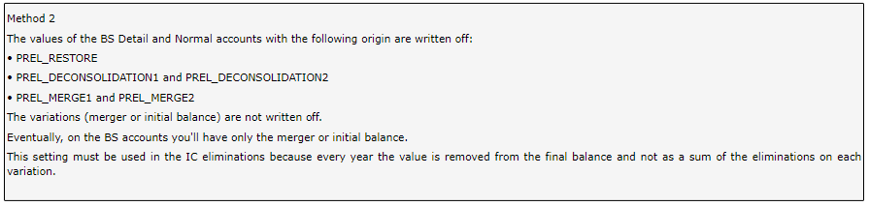
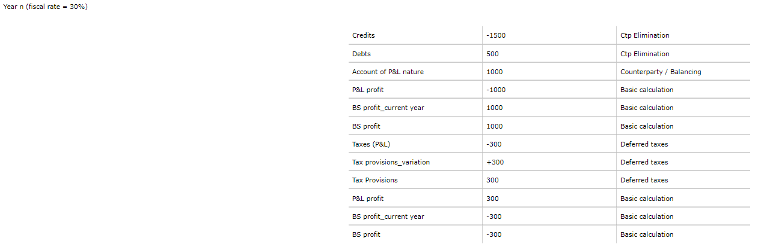

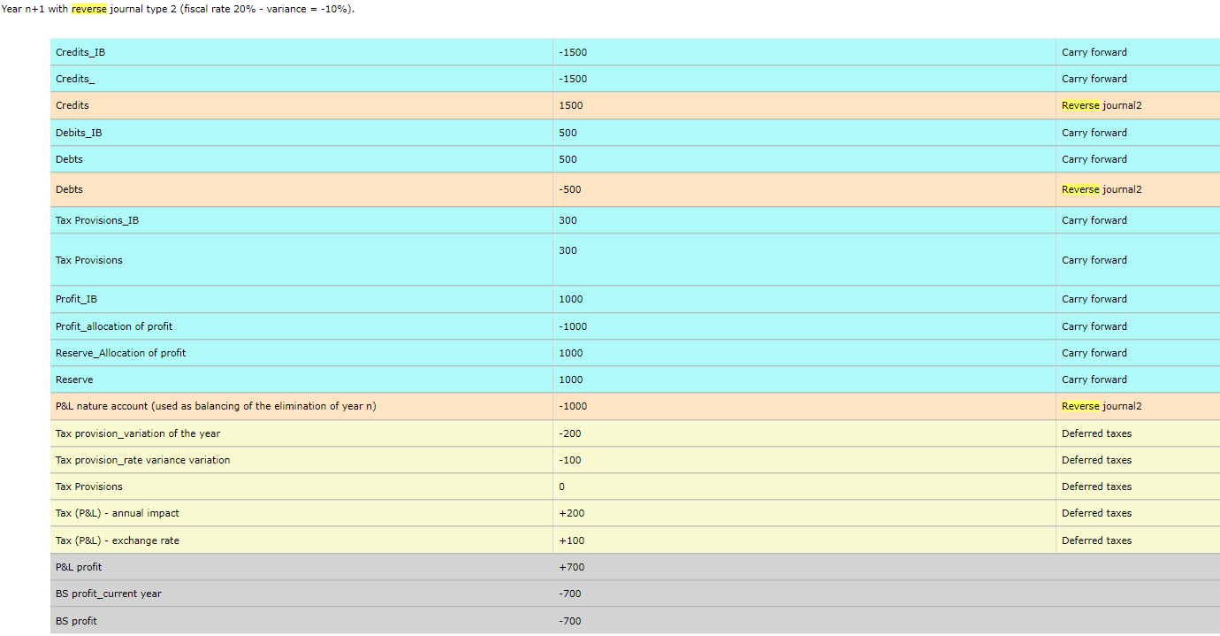

1.1.4.3 Method 3: Set BS accounts to 0, write off P&L impact and variations ("3")
Similar to type 2, except for the following differences:
The normal accounts of the deferred taxes and the related variations are excluded
The origin is PREL_REVERSE3
The variations (initial balance) are written off, except the Profit variation, using the variation defined on the opening entry
Also the Net Equity Accounts are written off except the Carry Forward one (the cancellation of the reserve is done by simply cancelling the P&L accounts present on the opening entry).
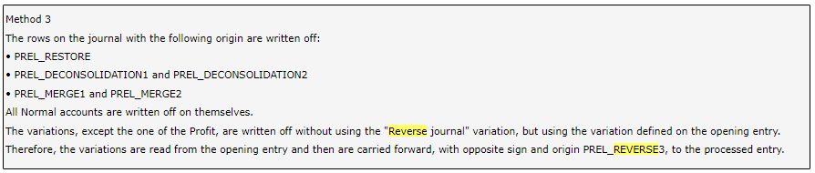

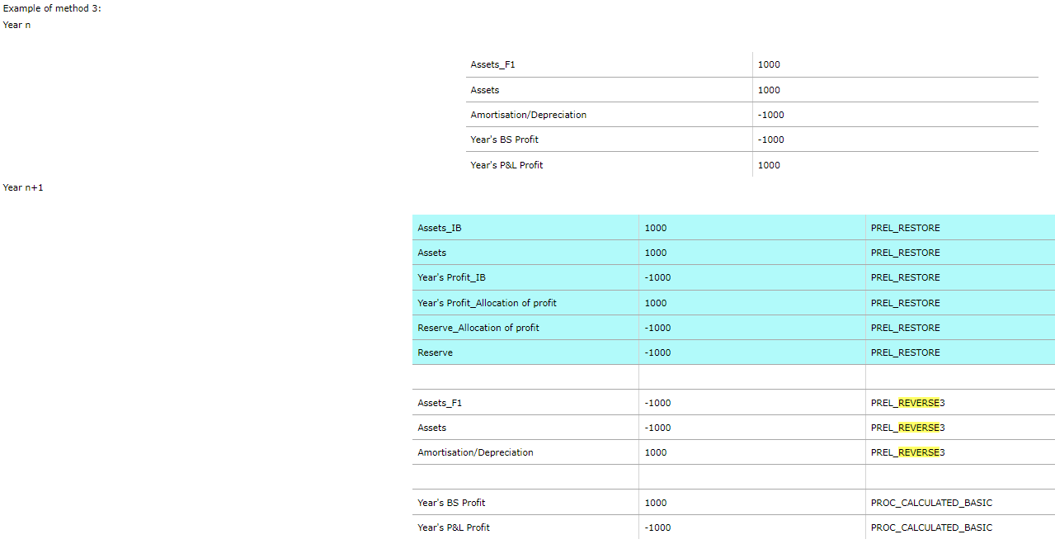

A step-by-step document is attached below.

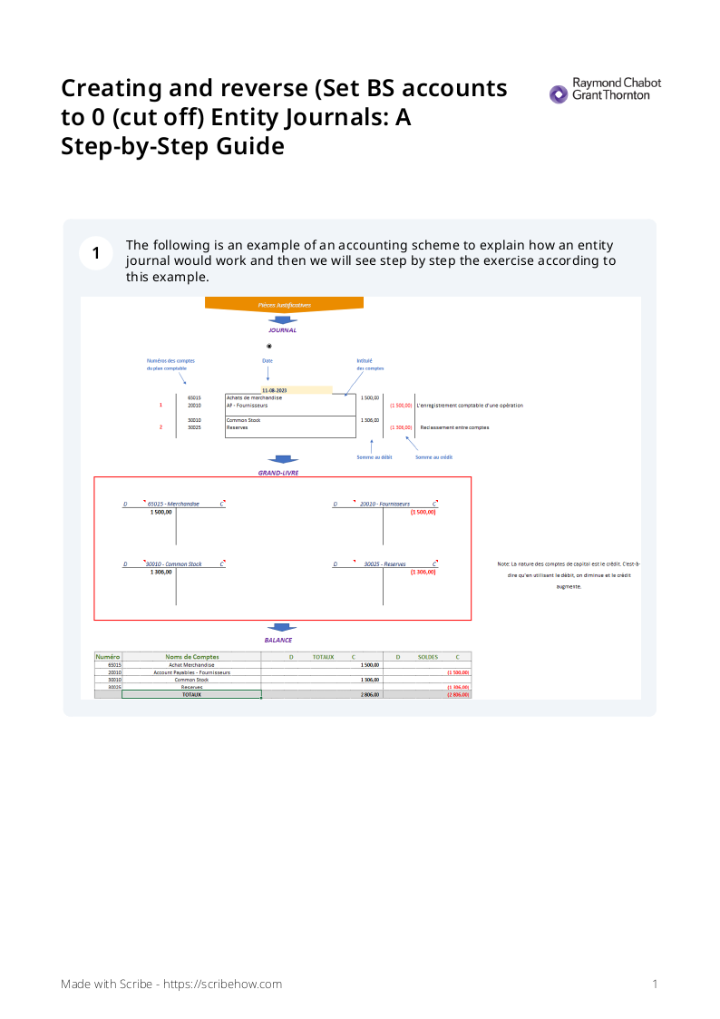

- Uploading Journal Data using an ETL:
It is possible to load the journals directly in Tagetik using an ETL, this ETL allows to load journals from an Excel file and using this ETL we can load many journals (Entity and consolidated) at once in stead of creating them manually one by one.
  - Journal Data ETL Configuration
The bellow table is a summary of the configuration that have been done on the ETL:
Source | Journals Data
Target CCH Tagetik Table | DATI_CAMBIO  DATI_NOTE  DATI_RETT  DATI_RETT_CAMBIO_CONS  DATI_RETT  DATI_RETT_RIGA  DATI_RETT_RIGA  DATI_RETT_SCENARIO_CONS  DATI_SALDI_IC  DATI_SALDI_LORDI
Format | Excel (xlsx)
Input Table
Mapping Table
Category
Custom Dim 1 | If Null Default Value: GEN
Custom Dim 2 | If Null Default Value: GEN
Custom Dim 3 | If Null Default Value: GEN
Custom Dim 4 | If Null Default Value: GEN
Custom Dim 5 | If Null Default Value: GEN
Frequency Upload | Quarterly
Scheduling Assistant | No
Data Type | Cumulated
Loading Strategy | Update and Insert By
Loading Strategy | Code
Estimated Volume | Pending
The Journal ETL is set to be used when users want to load journal entries, the ETL Loads data from an excel file in system tables, the journal Headers are Uploaded in “Entity Journals – Headers “ that is saved in the table “dati_rett” and the journal rows are Uploaded in “Original Journal Rows” and it is saved in the table “dati_rett_riga” .
The File that is used to load journals data is a standard template and it contains 4 Sheets:
- Data Entity Journal
- Override Data Entity Journal
- Data Consolidation Journal
- Override Data Conso Journal
each sheet allows to load data in a specific table and there are some columns that are mandatory, and some others are optional.
  - Journal Data Excel File Configuration
    - Entity Journal Upload File Sheets
Below are the elements needed to load entity journals data, the same elements are used in both sheets that are used for entity journals:

Element | Column Name in Tagetik Table | Corresponding Attribute in Tagetik Web | Mandatory / Optional
Scenario | COD_SCENARIO | Scenario | Mandatory Value needed
Period | COD_PERIODO | Period | Mandatory Value needed
Journal number | NUM_RETTIFICA | Journal prefix (in Header)  Journal Number (in Rows) | Mandatory Value needed
Entity | COD_AZIENDA | Entity | Mandatory Value needed
Account | COD_CONTO | Account | Mandatory Value needed
Custom dimension 1 | COD_DEST1 |  | Mandatory Value needed.  GEN is the default value
Custom dimension 2 | COD_DEST2 |  | Mandatory Value needed.  GEN is the default value
Custom dimension 3 | COD_DEST3 |  | Mandatory Value needed.  GEN is the default value
Custom dimension 4 | COD_DEST4 |  | Mandatory Value needed.  GEN is the default value
Custom dimension 5 | COD_DEST5 |  | Mandatory Value needed.  GEN is the default value
Category | COD_CATEGORIA | Category | Mandatory Value needed
Entity Ctp | COD_AZI_CTP |  | Depends on business requirement
Custom dimension 2 Ctp | COD_DEST2_CTP |  | Optional
Invoice currency | COD_VALUTA2 | Currency | Optional
Entity Ctp segment | COD_AZI_CTP_SEGMENT |  | Optional
Custom dimension 2 Ctp segment | COD_DEST2_CTP_SEGMENT |  | Optional
Amount | IMPORTO |  | Mandatory Value needed
Amount in Invoice currency | IMPORTO2 |  | Optional
F.I. event | NUM_EVENTO |  | Optional
Row notes | NOTE_RIGA |  | Optional
Additional row notes | NOTE_RIGA2 |  | Optional
Custom Dimension e Override type | TIPO_FORZATURA_DEST2_CTP |  | Optional
Override exchange rate | FLAG_FORZA_CAMBIO |  | Optional
Header notes | NOTE_TESTA |  | Optional
Manual override | FLAG_FORZATURA_MANUALE |  | Optional
To restore | FLAG_RIPRISTINO |  | Optional
End | FLAG_FINE |  | Optional
Filter Consolidation scenarios | FLAG_FILTRA_SCENARIO_CONS |  | Optional
Historical exch. Rate | FLAG_CAMBIO_STORICO |  | Optional
Taxes calculation type | TIPO_IMPOSTE |  | Optional
Reverse journals type | TIPO_ANNULLAMENTO |  | Optional
Documents attached | FLAG_DOCUMENTO |  | Optional
Periodic journal | FLAG_PERIODICO |  | Optional
Generator type | TIPO_GENERANTE |  | Optional
Table 1 - Options of entity journals
In the Excel file, there is 2 Sheets used to load data for the entity journals.

- Sheet 1: Data Entity Journal
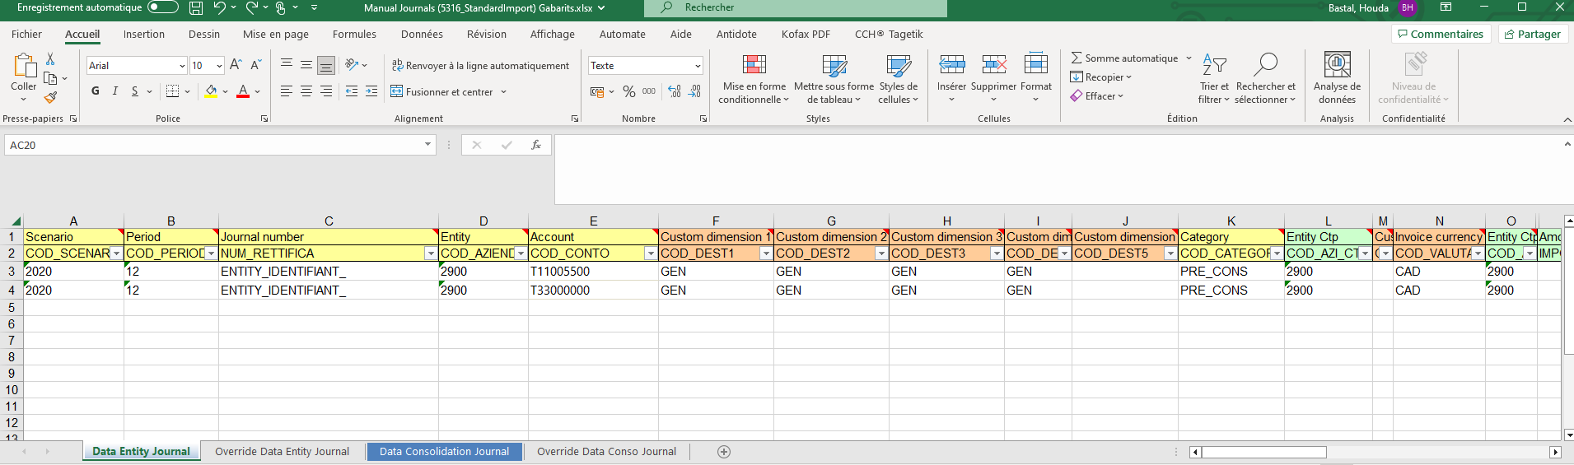
Screenshot 4 - Example of the Sheet 1 of the Journal File
- Sheet 2: Override Data Entity Journal
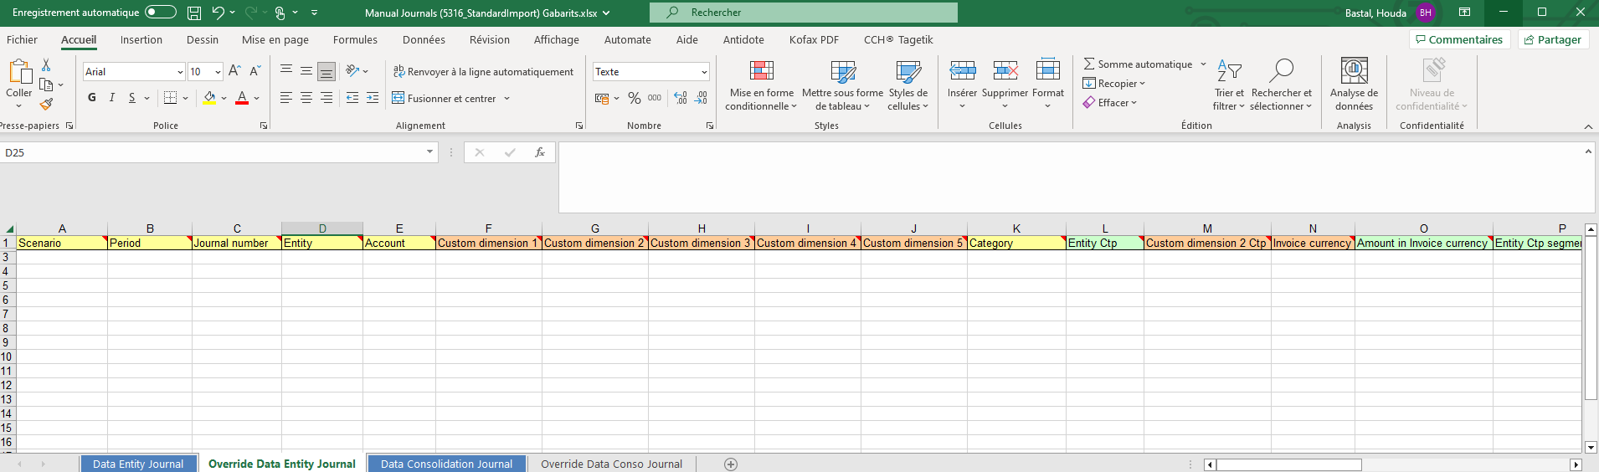
Screenshot 5 - Example of the Sheet 2 of the Journal File
When preparing these 2 sheets, for each row a value must be set for all the mandatory columns.
Once the rows are prepared, it is mandatory to make sure that the area is updated and covers all the rows that will be uploaded.
For the Data Entity Journal Sheet, the area is named “DATI_RETT_P”, and for the Override Data Entity Journal the area is named “DATI_RETT_P_FORZ”
The steps to update the area are described below:
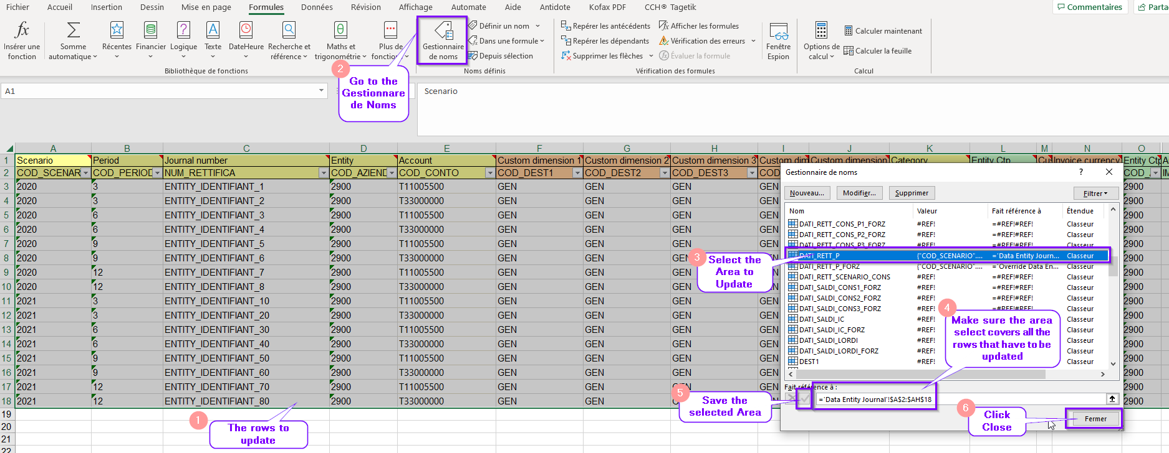
Screenshot 6 - the steps to update the area.

    - Consolidation Journal Upload File Sheets
The table below lists the elements needed to load Consolidation journals data, the same elements are used in both sheets that are used for Consolidation journals:
Element | Column Name in Tagetik Table | Corresponding Attribute in Tagetik Web | Mandatory / Optional
Scenario | COD_SCENARIO | Scenario | Mandatory Value needed
Period | COD_PERIODO | Period | Mandatory Value needed
Journal number | NUM_RETTIFICA | Journal prefix (in Header)  Journal Number ( in Rows) | Mandatory Value needed
Entity 1 of the header | COD_AZIENDA1 | Entity 1 | Mandatory Value needed
Custom dimension 2 Ctp of Entity 1 | COD_DEST21 |  | Mandatory Value needed. GEN is the default value
Entity 2 of the header | COD_AZIENDA2 | Entity 2 | Mandatory Value needed
Custom dimension 2 Ctp of Entity 2 | COD_DEST22 |  | Mandatory Value needed. GEN is the default value
Row's Entity | COD_AZIENDA | Entity | Mandatory Value needed
Account | COD_CONTO | Account | Mandatory Value needed
Custom dimension 1 | COD_DEST1 |  | Mandatory Value needed. GEN is the default value
Custom dimension 2 | COD_DEST2 |  | Mandatory Value needed. GEN is the default value
Custom dimension 3 | COD_DEST3 |  | Mandatory Value needed. GEN is the default value
Custom dimension 4 | COD_DEST4 |  | Mandatory Value needed. GEN is the default value
Custom dimension 5 | COD_DEST5 |  | Mandatory Value needed. GEN is the default value
Category | COD_CATEGORIA | Category | Mandatory Value needed
Entity Ctp | COD_AZI_CTP |  | Depends on business requirement
Custom dimension 2 Ctp | COD_DEST2_CTP |  | Optional
Declaring Entity's currency | COD_VALUTA2 |  | Mandatory Value needed
Amount in Declaring Entity's currency | IMPORTO2 |  | Mandatory Value needed
Entity Ctp segment | COD_AZI_CTP_SEGMENT | CTP Entity for Segment | Mandatory Value needed
Custom dimension 2 Ctp segment | COD_DEST2_CTP_SEGMENT |  | Mandatory Value needed. GEN is the default value
Currency | COD_VALUTA | Currency | Mandatory Value needed
Amount | IMPORTO |  | Mandatory Value needed
Transaction currency | COD_VALUTA_TRANSAZIONE |  | Optional
Transaction currency amount | IMPORTO_VALUTA_TRANSAZIONE |  | Optional
F.I. event | NUM_EVENTO |  | Optional
Row notes | NOTE_RIGA |  | Optional
Additional row notes | NOTE_RIGA2 |  | Optional
Custom Dimension e Override type | TIPO_FORZATURA_DEST2_CTP |  | Optional
Override exchange rate | FLAG_FORZA_CAMBIO |  | Optional
Header notes | NOTE_TESTA |  | Optional
No relationship | FLAG_NO_RAPPORTO |  | Optional
Manual override | FLAG_FORZATURA_MANUALE |  | Optional
To Restore | FLAG_RIPRISTINO |  | Optional
No N.E.R | FLAG_ESCLUDI_GPN |  | Optional
End | FLAG_FINE |  | Optional
Filter Consolidation scenarios | FLAG_FILTRA_SCENARIO_CONS |  | Optional
Historical exch. rate | FLAG_CAMBIO_STORICO |  | Optional
Equity method type | TIPO_EQUITY |  | Optional
Taxes calculation type | TIPO_IMPOSTE |  | Optional
Proportional % type | TIPO_PROP |  | Optional
Minorities | TIPO_TERZI |  | Optional
Minorities on Entity 1 | TIPO_TERZI_AZIENDA1 |  | Optional
Minorities on Entity 2 | TIPO_TERZI_AZIENDA2 |  | Optional
Reverse journals type | TIPO_ANNULLAMENTO |  | Optional
Documents attached | FLAG_DOCUMENTO |  | Optional
Periodic journal | FLAG_PERIODICO |  | Optional
Generator type | TIPO_GENERANTE |  | Optional
Table 2 - Options of consolidation journals
- Sheet 3: Data Consolidation Journal
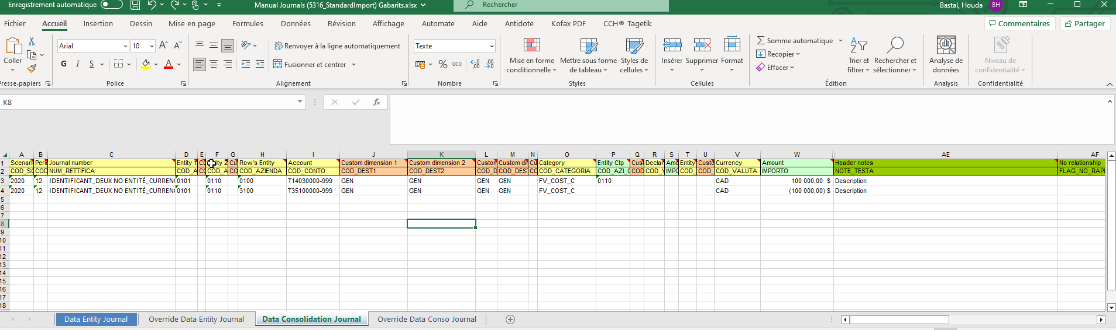
Screenshot 7 - Example of the Sheet 3 of the Journal File
- Sheet 4: Override Data Conso Journal

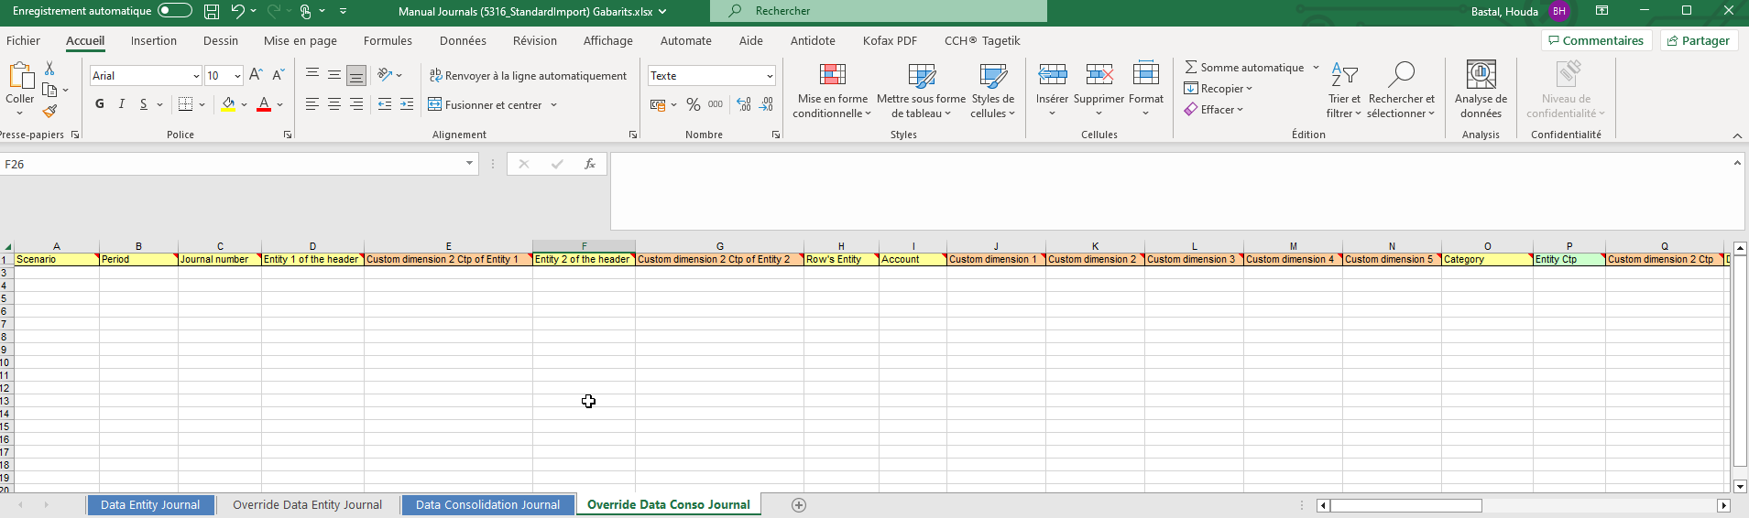
Screenshot 8 - Example of the Sheet 4 of the Journal File
When preparing these 2 sheets, for each row a value must be set for all the mandatory columns.
Once the rows are prepared, it is mandatory to make sure that the area is updated and covers all the rows that will be uploaded.
For the Data Consolidation Journal Sheet, the area is named “DATI_RETT_C”, and for the Override Data Conso Journal, the area is named “DATI_RETT_C_FORZ”
The steps to update the area are described below:
Screenshot 9 - the steps to update the area.
  - How to upload Journal Data using ETL
1. Click Execution:
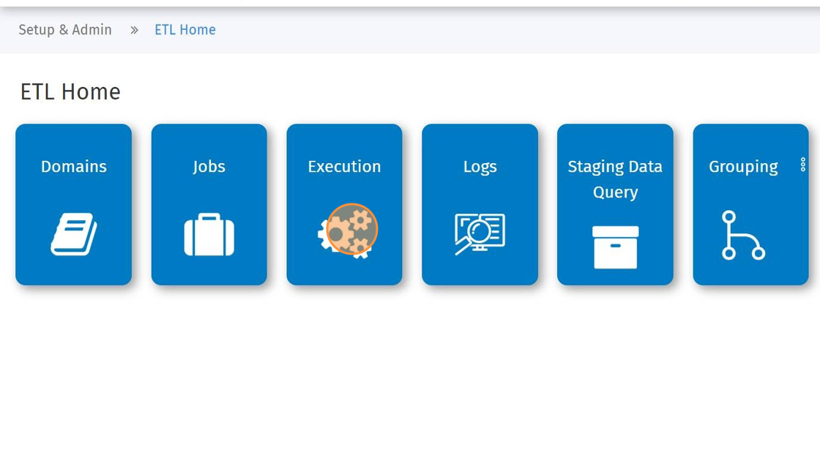
Screenshot 10 - Admin ETL Home Page

2. Select the Process
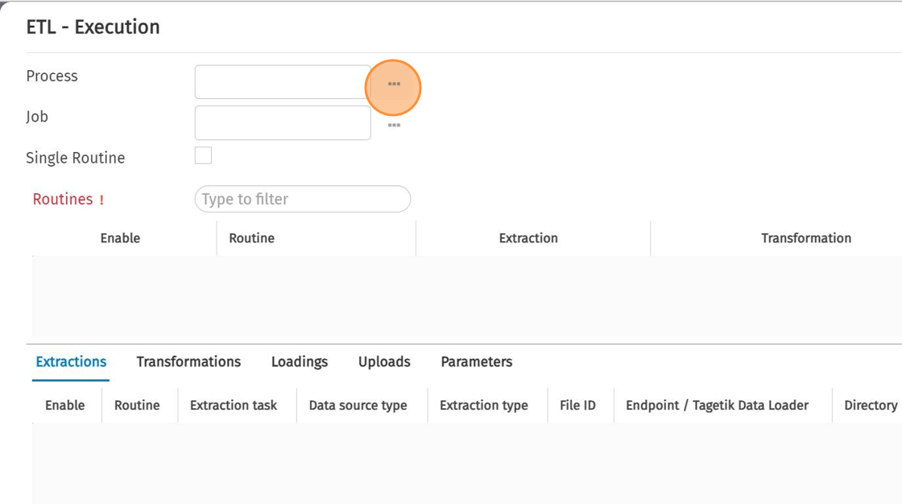
Screenshot 11 - getting the list of processes.
3. Click "Historical data recovery"
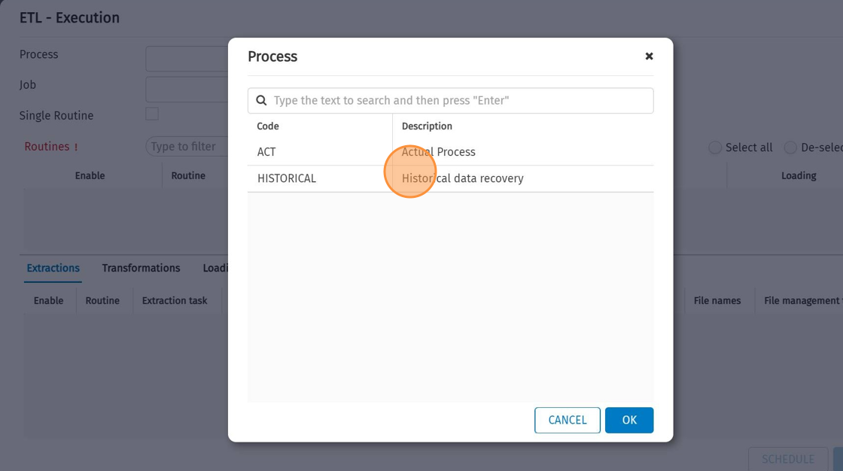
Screenshot 12 - Selection of the Process
4. Click "OK"
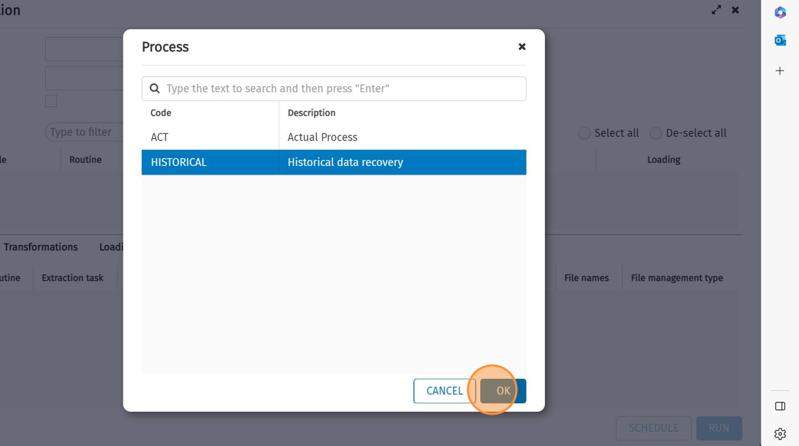
Screenshot 13 - Validation of the selected Process
5. Select the Job
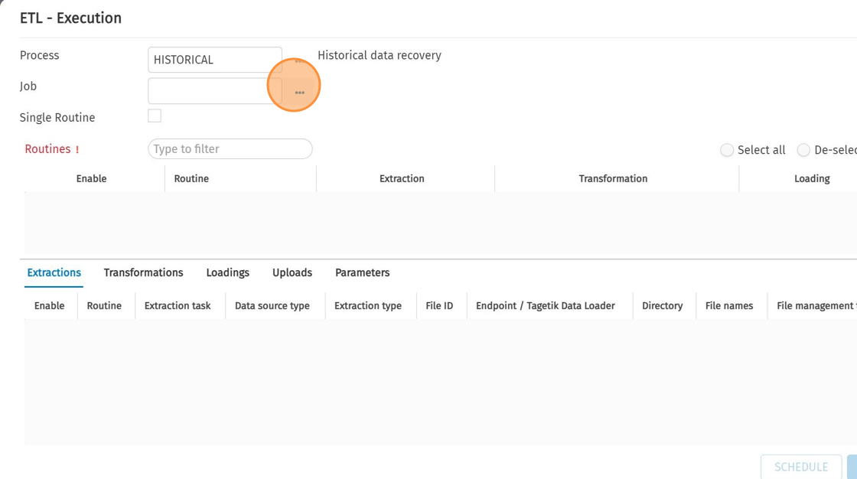
Screenshot 14 - Getting the list of jobs.
6. Click "Uploading Entity Journals"
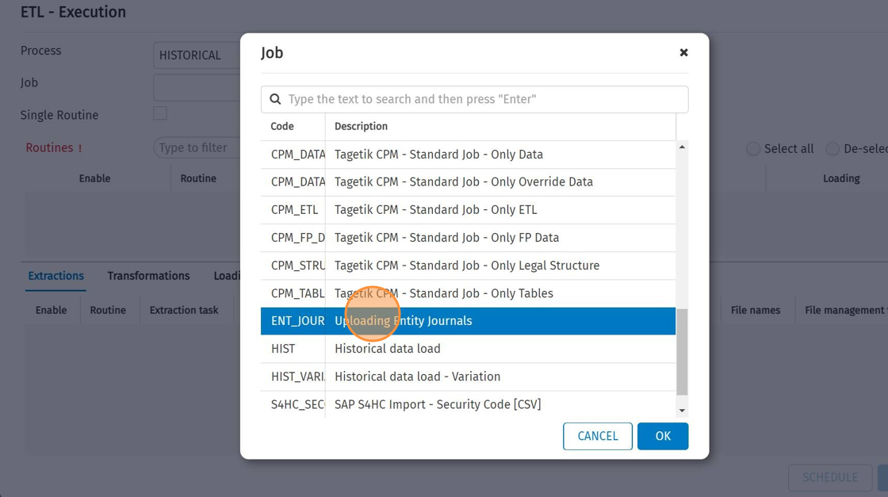
Screenshot 15 - Selection of the Job
7. Click "OK"
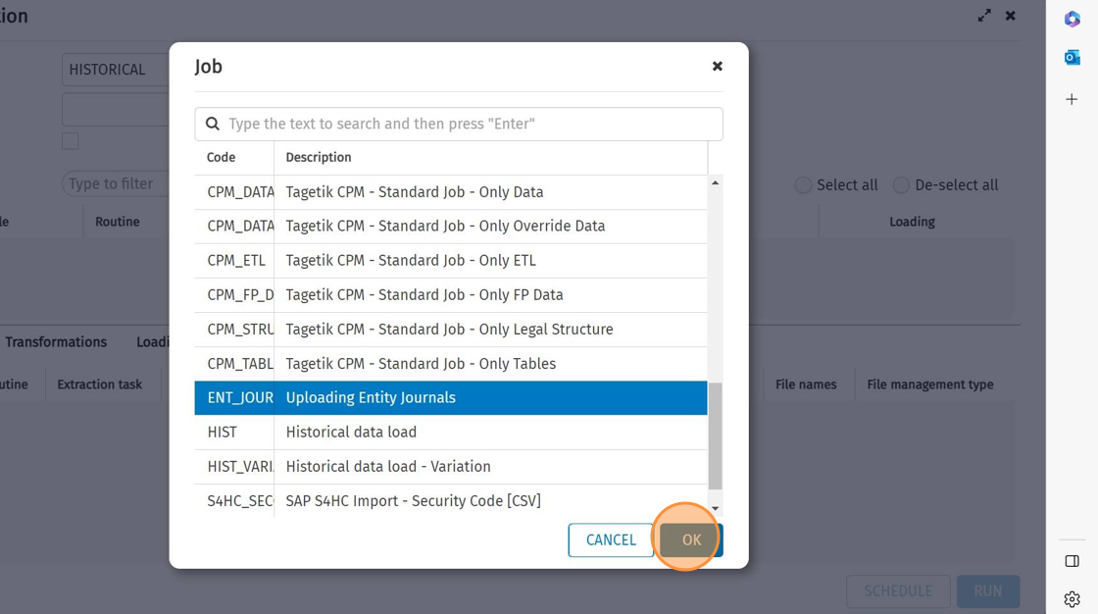
Screenshot 16 - Validation of the selected Job
8. Click "LOAD FILES"
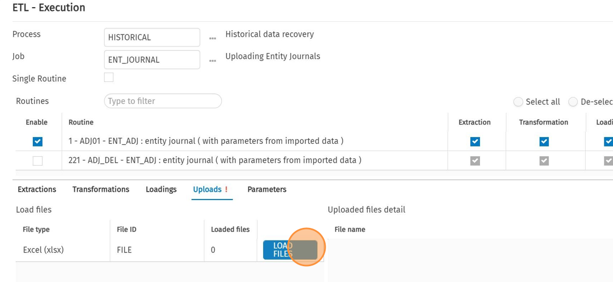
Screenshot 17 - Uploading the file.
9. select the Excel File to be Uploaded
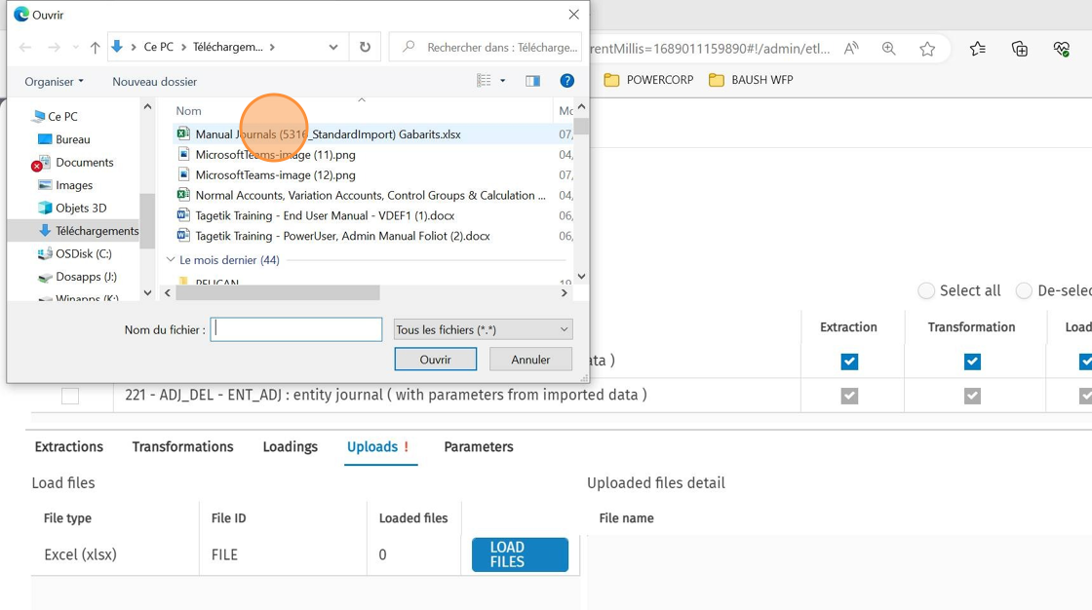
Screenshot 18 - Selection of the file to load
10. Click "Ouvrir"
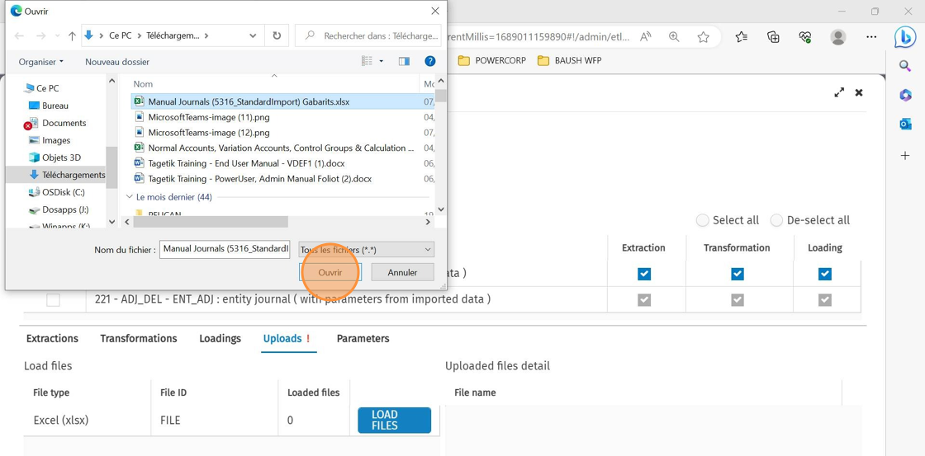
Screenshot 19 - validation of the selected file
11. Click "RUN"
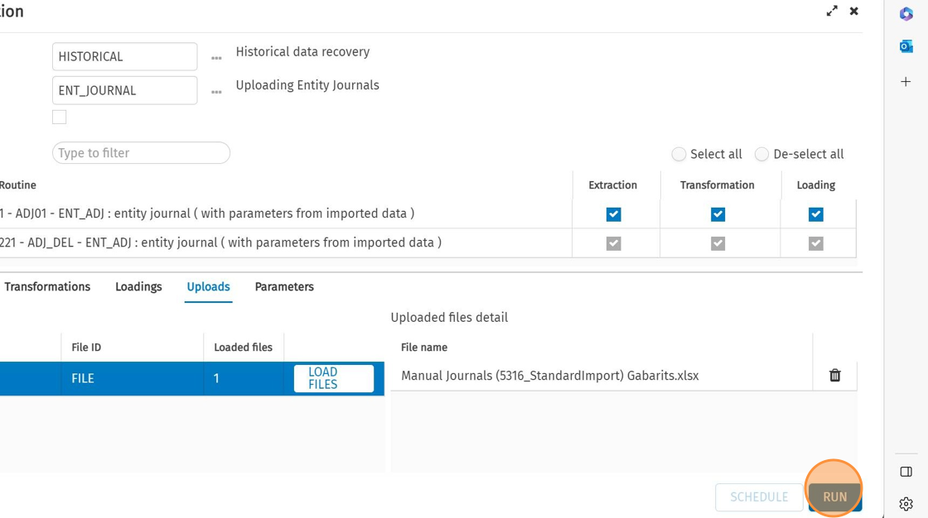
Screenshot 20 - Running the ETL
12. Select Scenario / Period and Entity
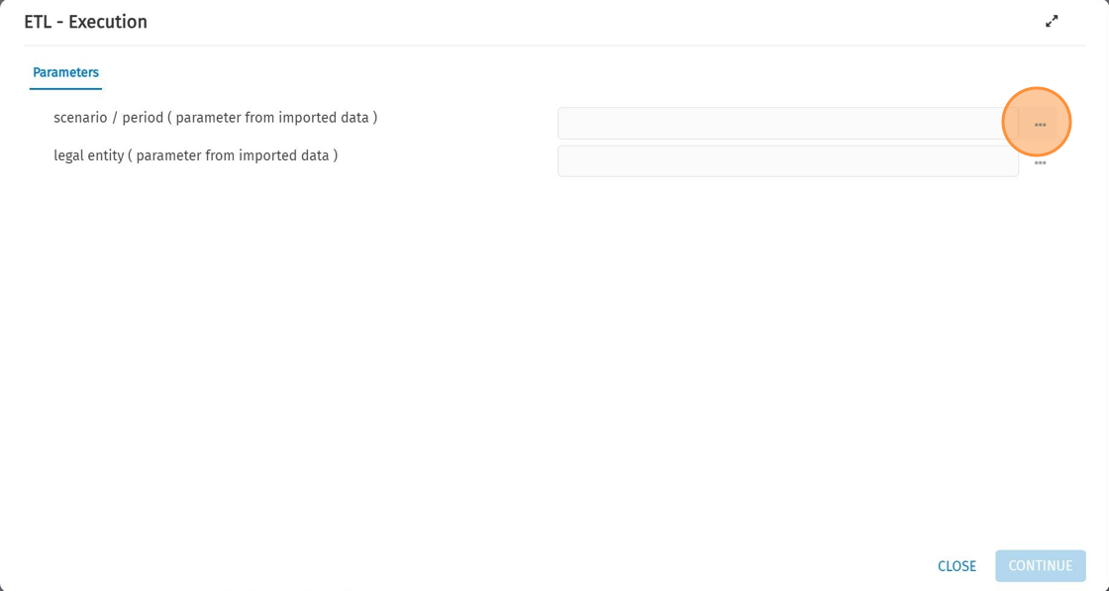
Screenshot 21 - Selection of Scenario, Period and Entity

The result of the Loading can be checked on the Logs section:
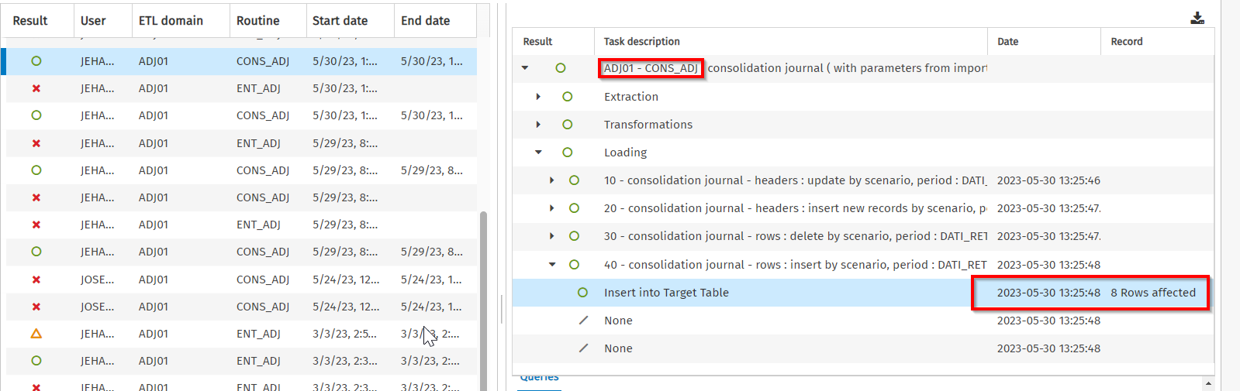
Screenshot 22 - ETL Execution Log
  - Common Errors
    - Error due to the value of the counterparty Entity:
This error occurs when the data to be Uploaded in Tagetik is for an intercompany account and the intercompany entity isn’t set:

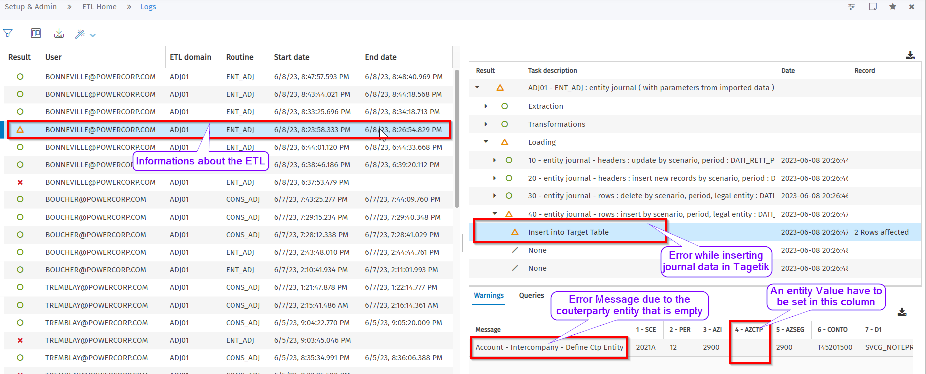
Screenshot 23 - ETL execution error due to an absent counterparty entity value
This issue can be resolved by setting an entity code in the counterparty column in the file that will be Uploaded or change the account to another one that isn’t intercompany, it depends on the functional need.

    - Error due to the category that is different between the header and the row:
The journals are added on two tables, one that contain the headers and another that contain the rows, both tables contain the category.
This error occurs when the category set on the header of the journal is different from the category set on the row.
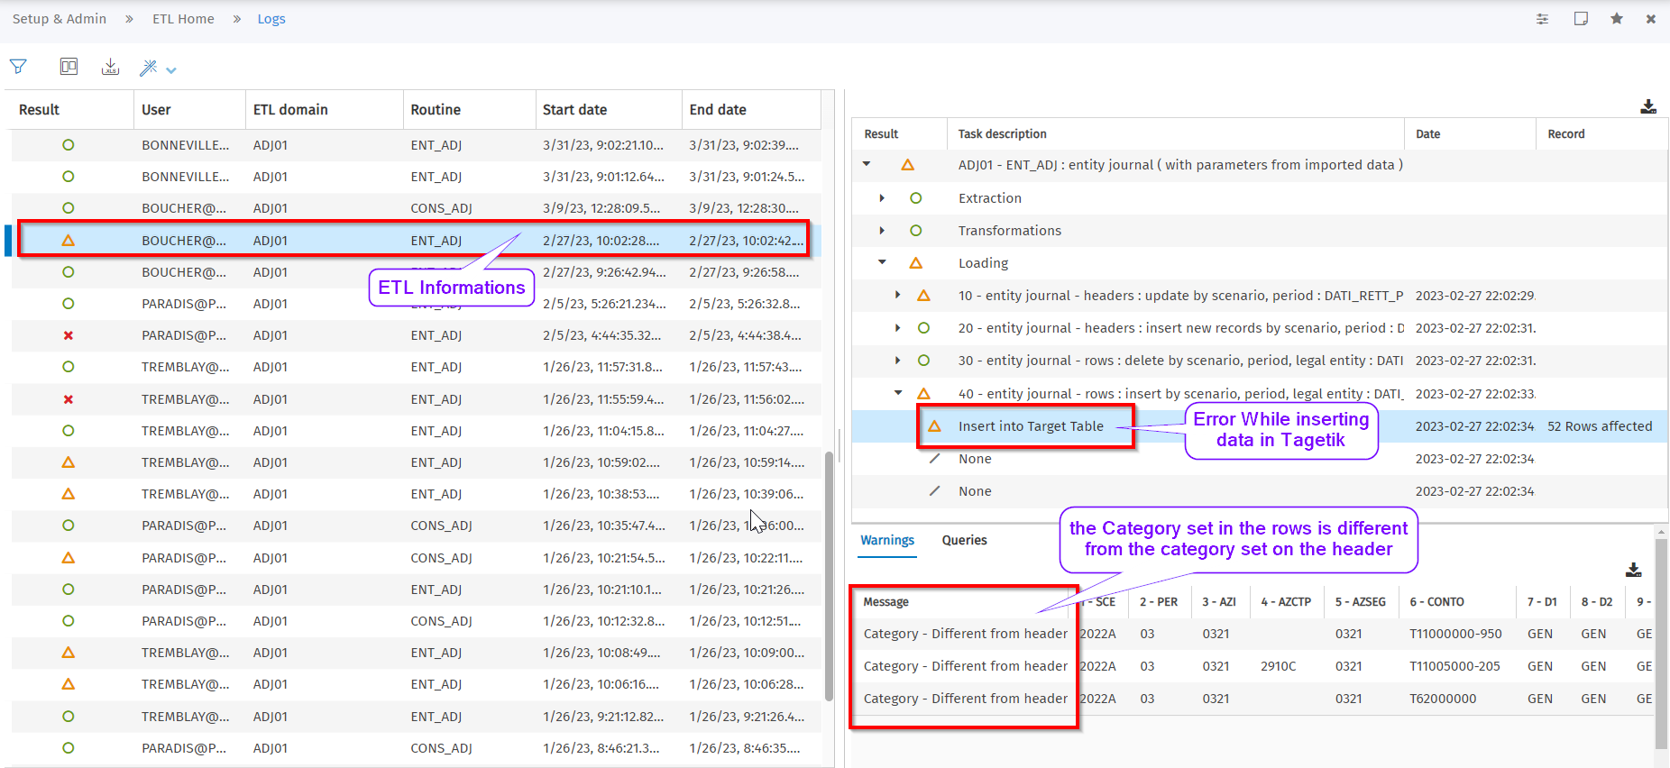
Screenshot 24 - ETL execution error due to the category value in journal rows
This error can be resolved by putting the correct category code in the category section.
    - The account code doesn’t exist:
This error occurs when the account set isn’t present in the Account dimension:
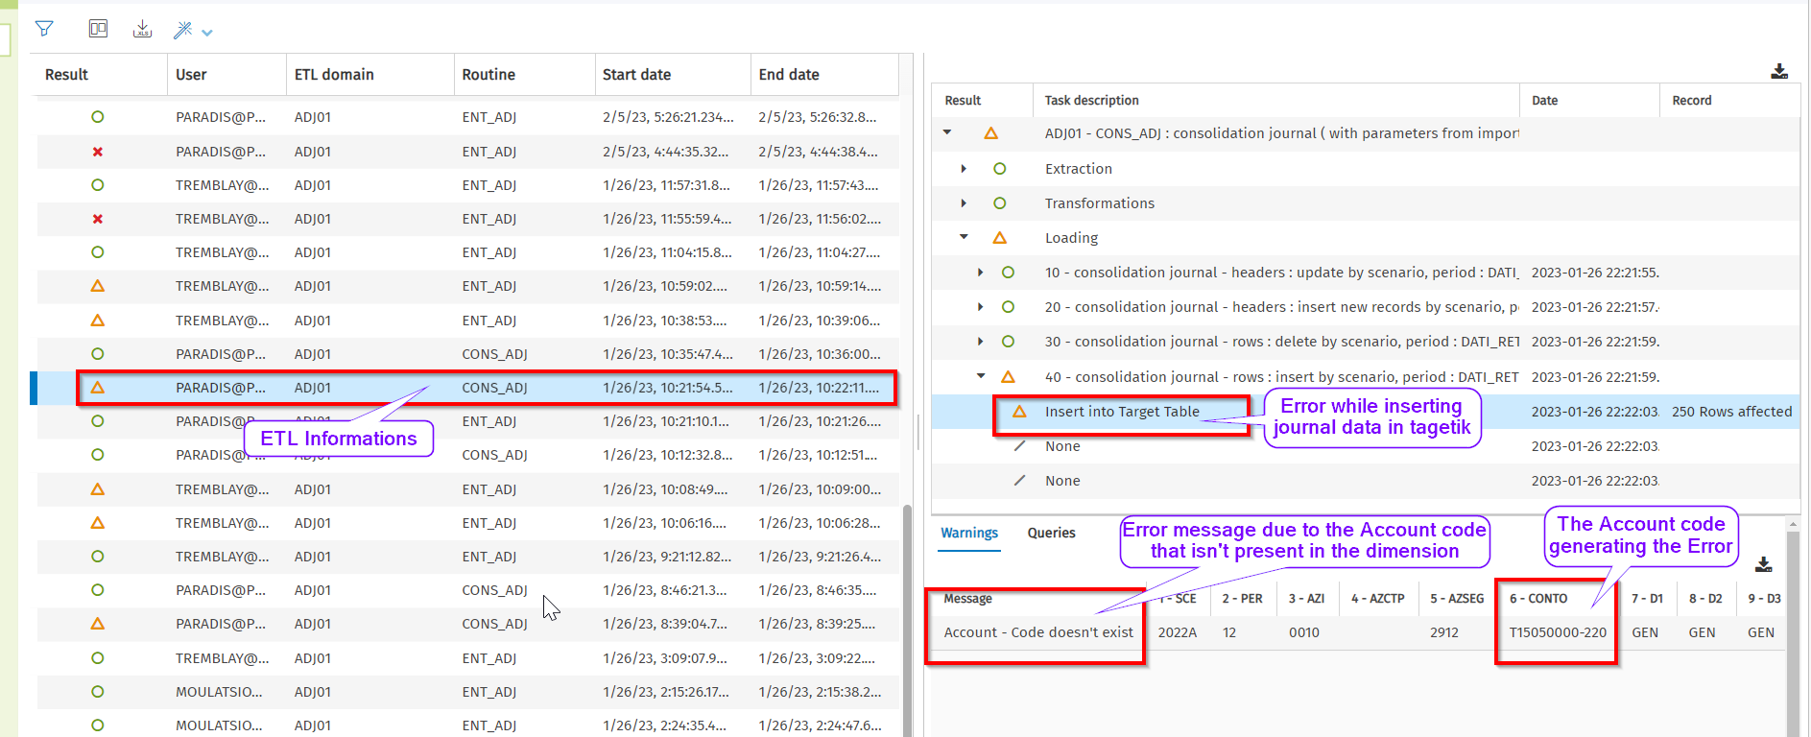
Screenshot 25 - ETL execution error due to the account code that doesn’t exist.
This error can be resolved by adding the account information to the account dimension, if this account can’t be part of the accounts list then the account code have to be changed to a correct one.
    - The Currency is different from the Header:
This error occurs when the currency set in the header of the journal isn’t the same that have been set in the row.
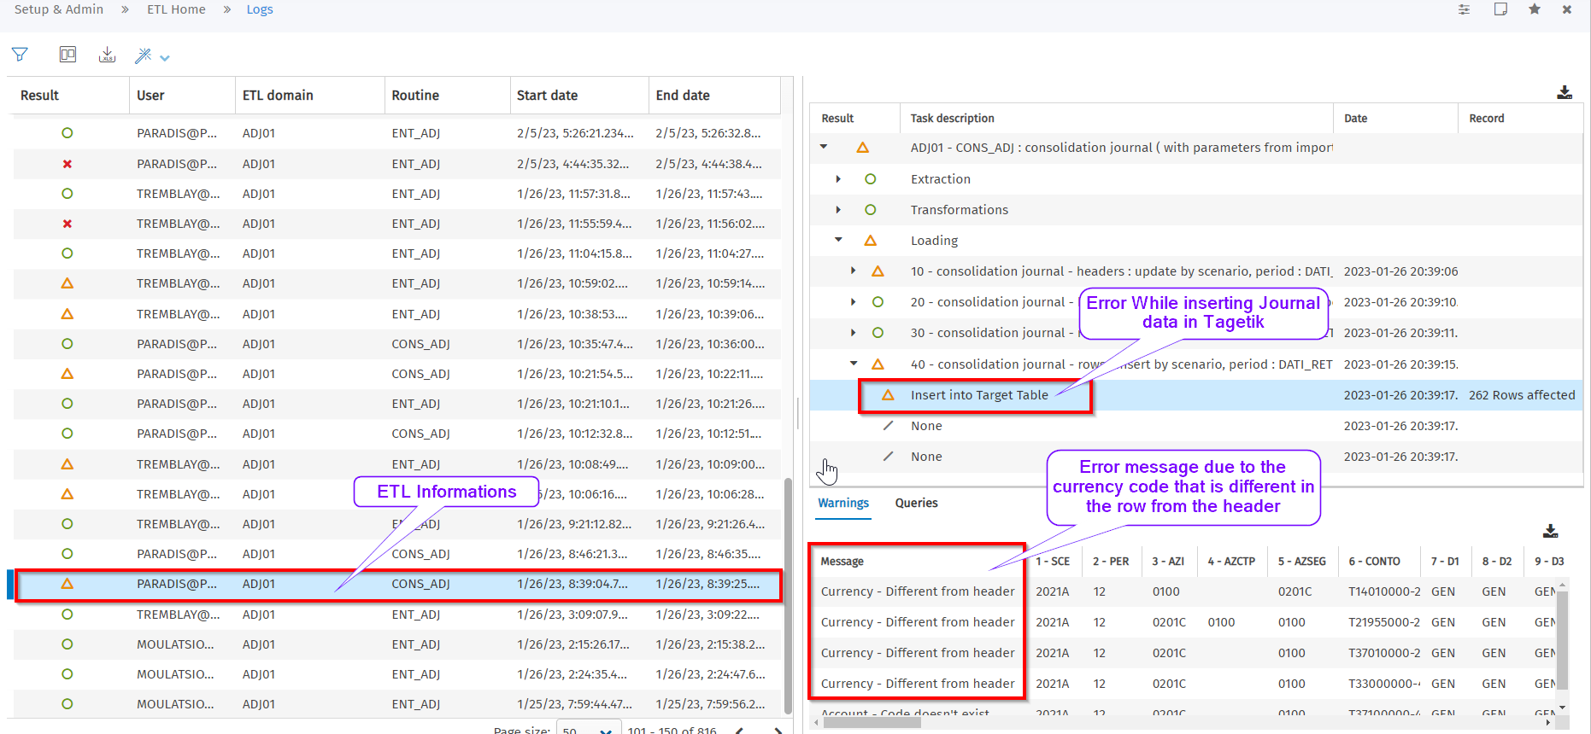
Screenshot 26 - ETL execution error due to the Currency value in the journal rows
This error can be resolved by putting the correct currency code in the currency section.

Failed: Corrected, failed, and approved:

We, the RCGT team, confirm that the expected result was obtained in the execution of this test, and we consider this test approved.

NAME | ROL | SIGNATURE

From Tagetik Help Data Entry
From Tagetik Help Data Entry
From Tagetik Help Data Entry
From Tagetik Help Data Entry
From Tagetik Help Data Entry
From Tagetik Help Data Entry
From Tagetik Help Data Processing
From Tagetik Help Data Processing
From Tagetik Help Data Processing

